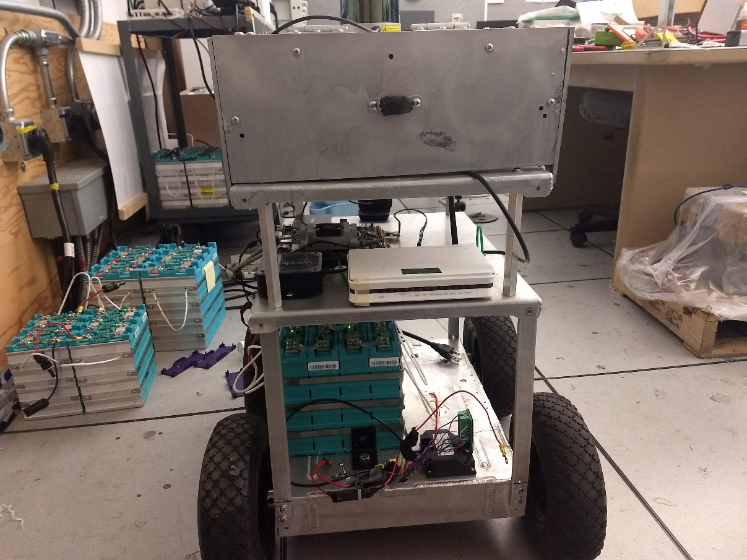

Development of autonomous electric delivery drone using ROS and CAD tools

Dacheng Li

Faculty supervisors: Dr. Peter Chu and Dr. Rajit Gadh

UID: 305-009-522

3/15/2020

***Abstract-* This paper represents one of my two end products for the MAE 199 course, outlining the process and result from my work in developing a self-driving delivery vehicle. The project took place during winter quarter of the 2020 academic year under the supervision of Dr. Rajit Gadh and Dr. Peter Chu. Through the use of machining and CAD tools, I was able to construct a drone with a large cargo capacity, high operational time, and ruggedized chassis for future deployment on the UCLA campus. Further design work was done with ROS modeling, using its built-in capabilities for easy programming and simulation of our rover.**

***Index terms-* self-driving, SLAM,LIDAR, autonomous, logistics, cargo vehicle**

# INTRODUCTION

With the advent of modern connectivity technologies, IoT is emerging trend in the road to a more connected future. Indeed, when combined with self-driving vehicles, these developments can help further improve the standard of life around the world. However, due to the amount of time it would take to develop a fully autonomous vehicle, my research focuses on the hardware and simulation that would be required to bring such a project to fruition. Indeed, while there are many self-driving logistics vehicles already rolling, many of their systems are based on a combination of GPS and camera sensors. Most notably, the Kiwibots of Berkeley have been operational for a number of years and are well received by the community. However, primarily due to their small stature and limited instrument suite, they are not well suited for a long-duration, high capacity delivery role. Indeed, the practical demonstration of such a project would greatly innovate delivery services with the availability of such a high capacity, long duration platform. With the 2019 coronavirus outbreak, maybe it’s time to start relying more on autonomous delivery services to serve our resource needs.

Initial designs for the rover actually began before my time, with the platform debuting as a mobile battery for smartgrid applications. After a short stint as a parking violation detector, the vehicle (henceforth referred as “Troggie”) was repurposed into its current form as an autonomous delivery vehicle. Preliminary development into this new form began with a replacement of the vehicle’s electrical inverter, which had broken in a previous test. This necessitated a complete redesign of the entirety of the mechanical system (figure 1), which was done through SOLIDWORKS 2019. After some brief analysis into the weight distribution of the vehicle, development moved onto the programming of the vehicle’s software in ROS and testing of core systems. However, it was during this time that I was severely bedridden for illness, which greatly slowed down development. Additionally, during the latter weeks of development, progress was dramatically halted by the onset of the COVID-19 outbreak. As such, this 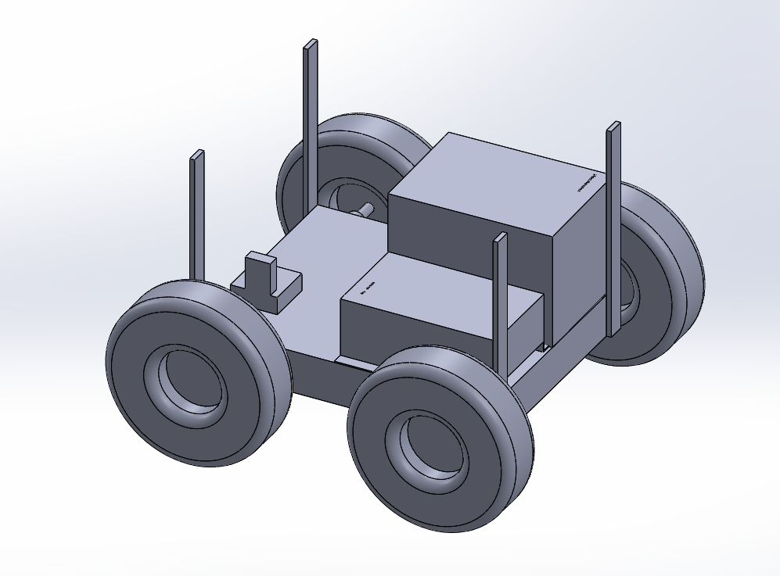document details what development I was able to accomplish.

Figure : Troggie's lower assembly, containing the power system and drivetrain

# Difference from existing platforms

This vehicle is not the first attempt at an autonomous delivery vehicle. With existing platforms like Columbia’s Kiwibot and Amazon’s Scout platform, the concept is already in action delivering products to consumers around the world. As such, this development seeks to differentiate itself from the competition by allowing transportation of larger objects over a longer range, at the detriment of having a higher cost margin. This, combined with recent FAA regulations against widespread UAV platforms, allows Troggie to better compete in an already crowded market for a niche role which has not already been filled.

# Materials and methods

Because Troggie is an upscaling and reimagining of the old ‘Antbot’ platform, it shares much of the older vehicle’s hardware. As such, the core components in this redesign are comprised of the following:

* Velodyne VLP-16 LiDAR
* Jetson TX2 Developer Kit
* SparkFun 9DoF Razor IMU M0
* RoboteQ SDC2130 - 2x20A 30V Motor Controller with Encoder Input
* Samsung 850 EVO 250GB 2.5-Inch SATA III Internal SSD
* 24V LiFeMnPO4 Prismatic Battery 60Ah
* Superdroid IG52-DB4, 4WD All Terrain Heavy Duty Robot Platform (with customized upper deck)
* D-Link Wireless AC1200 Dual band router
* AmazonBasics 6-Outlet Surge Protector Power Strip
* WZRELB Pure Sine Wave Inverter DC to AC 24VDC

The initial chassis redesign took place primarily to account for the new inverter, which had replaced the previously damaged component. This change allowed us to use a smaller, lighter battery than the previous iteration. With this change came a rearrangement of all electronics to compensate. This had the added benefit of allowing a shortening of all wires and cables for higher efficiency and easier cable management. Next, the decision was made to begin design of a cargo carrying module out of a strong polycarbonate material. The decision was made to use high-density polyethylene to give the cargo module high strength and durability. This would allow the vehicle to take a few low-speed collisions and still complete its trip without a return to a repair facility. However, due to material constraints, the module would have just over a cubic foot of carrying volume, slightly higher than existing platforms but slightly short of a true high-capacity role.

The software development section had been scheduled for an update shortly after the completion of the cargo module. However, due to time and personal health constraints, work on this aspect of the platform was moved up with an emphasis on simulation and proof of concept. It was during this time that a manufacturing defect was discovered in the new inverter, rendering the module unsuitable for our needs. Thus, the decision was made to push forward with a model of the system as a modification of the ROS turtlebot simulation with a LIDAR modification. This was deemed a system similar enough to ours to serve as a proof of concept, allowing for a positive simulation of the LIDAR for navigational purposes.

# Results

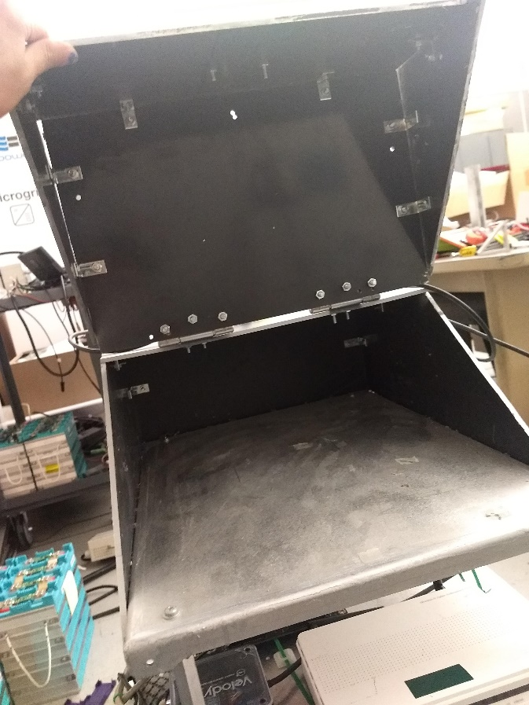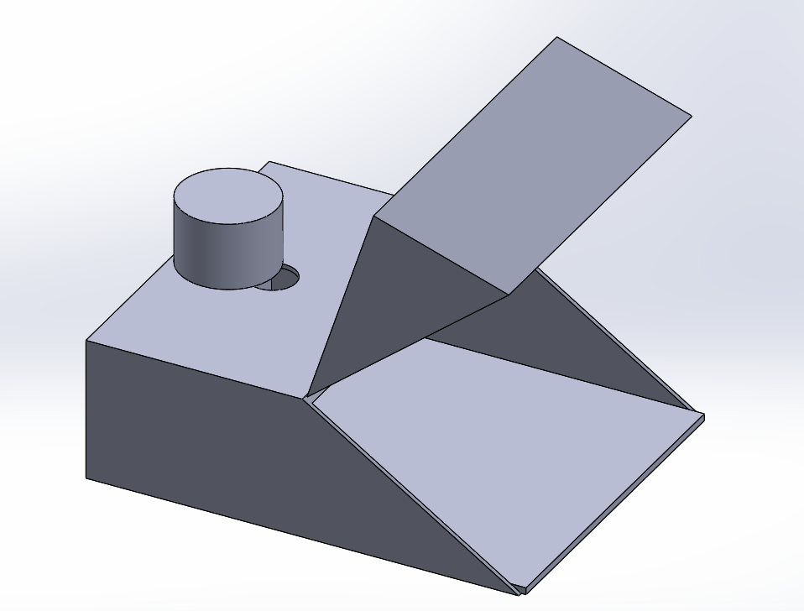Starting from a redesign of an existing platform, we already had high hopes for the outcome of this project. By using CAD and other design tools to help us plan ahead, we were able to verify fit clearances and design tolerance levels for the new cargo module, a model and comparison of which can be seen below.

When we fit this to our primary platform, it raised the center of gravity slightly but gave the design a healthy cargo capacity to transport heavy payloads. Indeed, the cargo capacity of just over one cubic foot allows us to transport nearly one whole Kiwibot. The software redesign phase was less successful, as although we were able to get our simulated platform to run through a pre-scanned version of 4th floor ENG IV, seen below, the travel times did not suit what we were expecting. 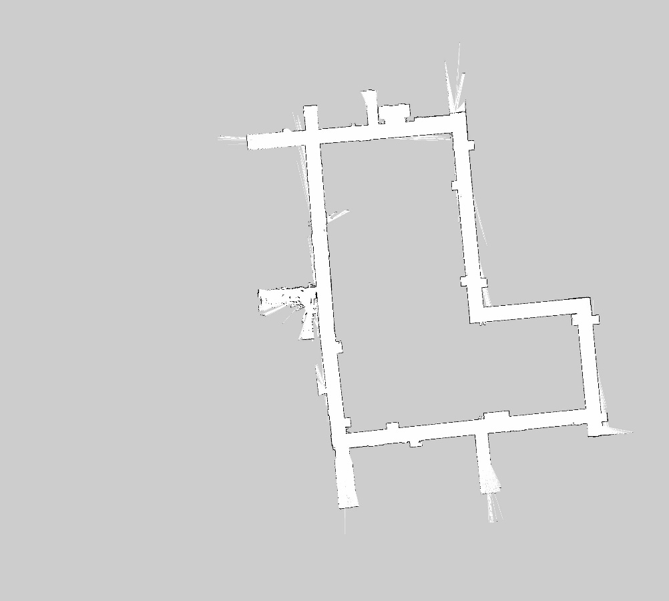Indeed, the algorithm that was used caused troggie to travel like a snake down the hallways. Were it not for the COVID-19 outbreak and the shutdown of the lab, this issue may have been patched out. However, due to these circumstances and numerous health concerns during the year, the software algorithms which drive troggie remain patchy at best.

Figure : Troggie's cargo assembly- top. Actual build, right

Figure : LIDAR map of ENG IV, taken many months ago

# Conclusion

This report comprises a general outline for the design of an autonomous delivery vehicle. Although the primary goal of a fully functioning delivery drone was not reached, a lot of progress was made on the proof of concept and physical chassis of the platform. Thus, the following challenges remain ahead:

* Full redesign of the electrical system: The original plan was to use an inverter to connect all the core systems up to the battery. However, due to circumstances involving the manufacturing of the component, the system must be rewired to ensure full operation.
* Lightening of the chassis: The current design to use the existing super heavy-duty robot platform does not allow for extensive modification and is not energy efficient. Thus, it may be prudent to swap out the chassis for a lighter carbon fiber version.
* Addition of additional batteries: There isn’t much room to place additional batteries on the current version of our platform. However, with some modifications to the chassis, the platform may be able to gain additional range and cargo capabilities
* Full simulation of platform: While the current LIDAR simulations suffice for a core proof of concept, additional simulation of the platform performing in a variety of environments will help “seal the deal” and help advance the TRL in preparation for a real-life deployment.
* Building of additional platforms: While having one model is sufficient for current research purposes, a real-life deployment of Troggie’s for logistical work would require a small fleet of robots. Thus, it may be prudent to develop a number of platforms in order to enhance and test the networking capabilities of our design.
* Addition of GPS/Radio capabilities: During simulations, the LIDAR system worked well for navigational purposes. However, in a real-world environment, it may be prudent to have multiple sensor packages to ensure full coverage in a variety of conditions. Thus, one of the next implementations for the project would additional communications equipment and GPS networking.
* Security: The world of IoT devices allows for increasingly complex networks and additional capabilities for existing devices. However, it also comes with a huge amount of security risks which must be accounted for if the platform has any future in real-life conditions.

In essence, the design and build of an autonomous logistics vehicle was the main goal of this research. It is hoped that, with this knowledge, future iterations on this platform will be able to finish construction and implementation of this vehicle in a real-world delivery setting.

# References

High Definition 3D Map Creation Using GNSS/IMU/LiDAR ... [www.researchgate.net/publication/339111971_High_Definition_3D_Map_Creation_Using_GNSSIMULiDAR_Sensor_Integration_to_Support_Autonomous_Vehicle_Navigation](http://www.researchgate.net/publication/339111971_High_Definition_3D_Map_Creation_Using_GNSSIMULiDAR_Sensor_Integration_to_Support_Autonomous_Vehicle_Navigation).

Huang, L. (2010). LIDAR, Camera and Inertial Sensors Based Navigation Techniques for Advanced Intelligent Transportation System Applications. UC Riverside. ProQuest ID: Huang_ucr_0032D_10326. Merritt ID: ark:/13030/m5p84fr3. Retrieved from <https://escholarship.org/uc/item/1p02x8xg>

J. Moras, V. Cherfaoui and P. Bonnifait, "A lidar perception scheme for intelligent vehicle navigation," 2010 11th International Conference on Control Automation Robotics & Vision, Singapore, 2010, pp. 1809-1814.

Joerger, Mathieu et al. “A New Approach to Unwanted-Object Detection in GNSS/LiDAR-Based Navigation.” Sensors (Basel, Switzerland) vol. 18,8 2740. 20 Aug. 2018, doi:10.3390/s18082740

K. Koide, J. Miura, and E. Menegatti, A portable three-dimensional LIDAR-based system for long-term and wide-area people behavior measurement, Int. J. Adv. Robot. Syst., vol. 16, no. 2, p. 172988141984153, Mar. 2019.

VEHICLE RECOGNITION FROM LIDAR DATA. pdfs.semanticscholar.org/128d/4f428cbfa7f936e6806c4122c06c63eb5040.pdf.

# Appendices

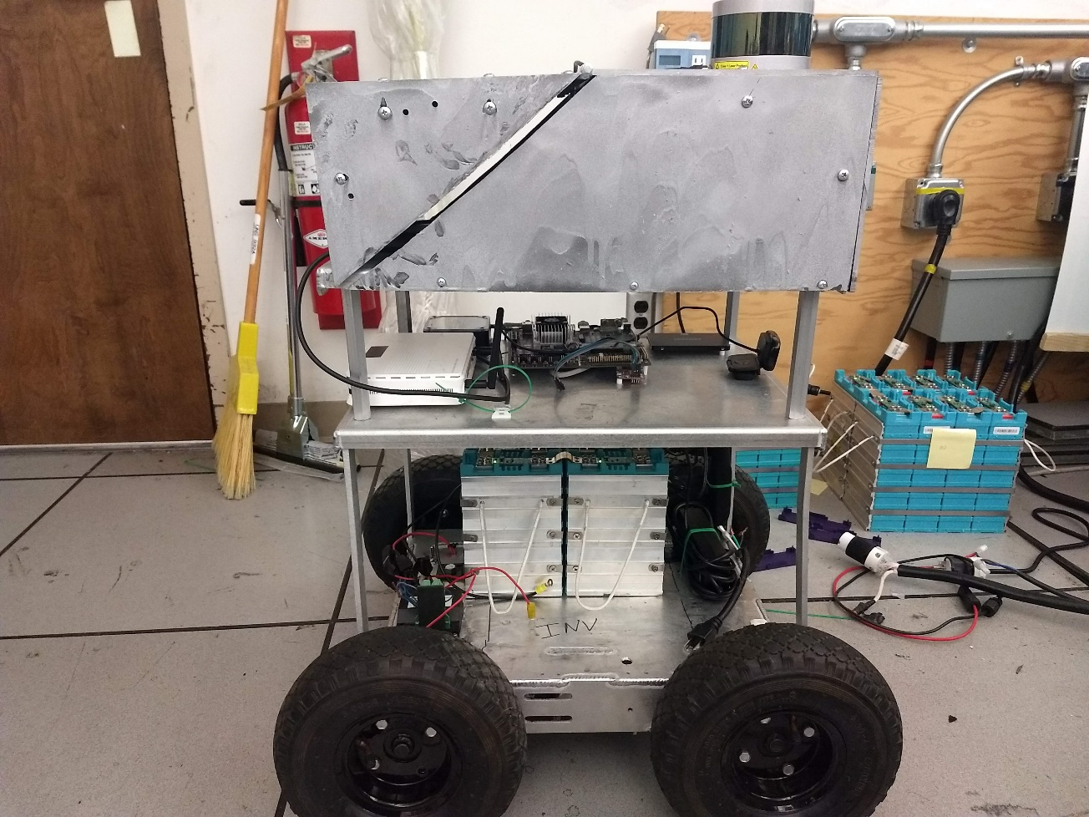

Right side view

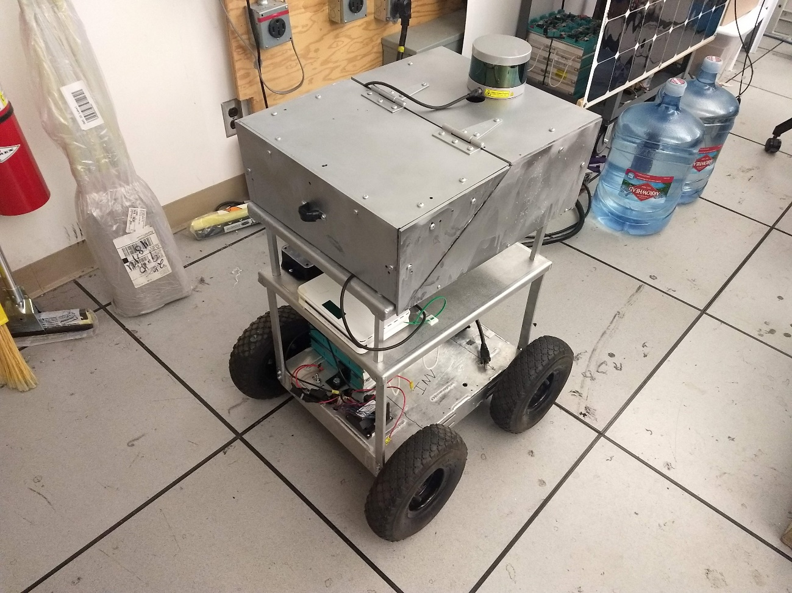Orthorhombic view 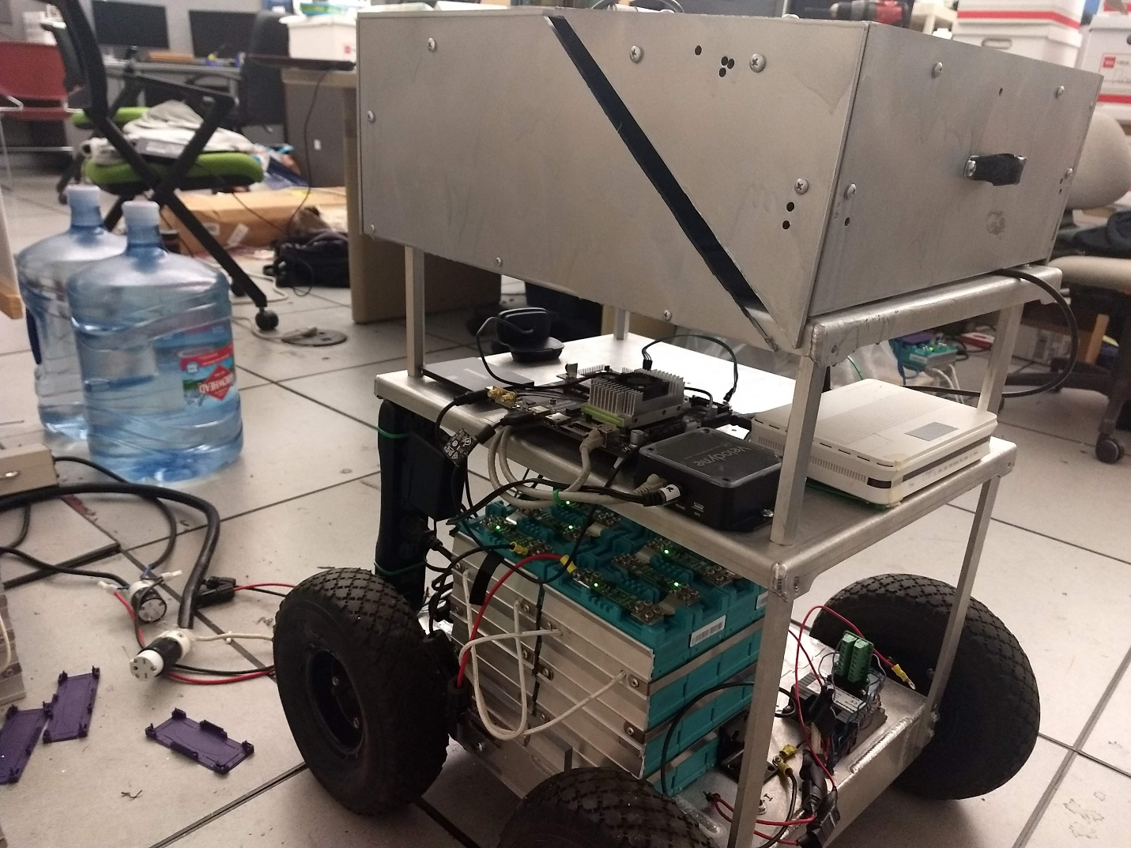

Left side view, showing additional mounting options for cargo module